**Quick Start Tutorial**

This chapter provides a tutorial on how to use EPANET.

## **Installing EPANET:**

## EPANET Version 2.2 is designed to run under the Windows 7/8/10 operating system of an Intel-compatible personal computer. It is distributed as a single installer package file, **epanet2.2_setup.exe**.

## **Example Network:**

In this tutorial we will analyse the simple distribution network shown in [Figure](https://epanet22.readthedocs.io/en/latest/2_quickstart.html#fig-ex-pipe-network) below. It consists of a source reservoir (e.g., a treatment plant clears well) from which water is pumped into a two-loop pipe network. There is also a pipe leading to a storage tank that floats on the system. The ID labels for the various components are shown in the figure. The nodes in the network have the characteristics shown in [Table 1](https://epanet22.readthedocs.io/en/latest/2_quickstart.html#table-ex-network-node-prop). Pipe properties are listed in [Table 2](https://epanet22.readthedocs.io/en/latest/2_quickstart.html#table-ex-network-pipe-prop). In addition, the pump (Link 9) can deliver 150 ft of head at a flow of 600 gpm, and the tank (Node 8) has a 60-ft diameter, a 3.5-ft water level, and a maximum level of 20 feet.

Figure



Figure1: Example pipe network.

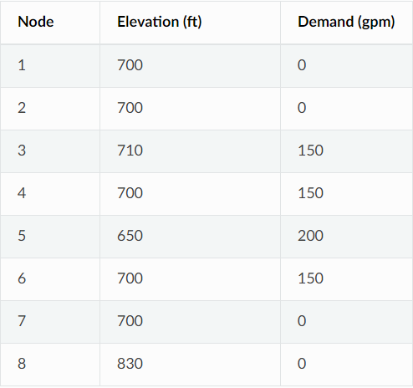 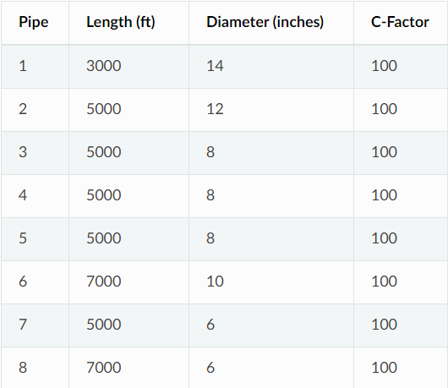

Table1: Example Network Node Properties Table2: Example Network Pipe Properties

**Project Setup:**

Our first task is to create a new project in EPANET and make sure that certain default options are selected. To begin, select **File >> New** (from the menu bar) to create a new project. Then select **Project** **>> Defaults** to open the dialog form shown in Figure 2. We will use this dialog to have EPANET automatically label new objects with consecutive numbers starting from 1 as they are added to the network. On the ID Labels page of the dialog, clear all of the ID Prefix fields and set the ID Increment to 1. Then select the Hydraulics page of the dialog and set the choice of Flow Units to GPM (gallons per minute). Also select Hazen - Williams (H-W) as the head loss formula. If you wanted to save these choices for all future new projects you could check the **Save** box at the bottom of the form before accepting it by clicking the **OK** button.

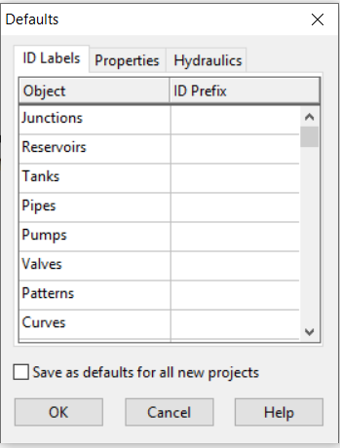 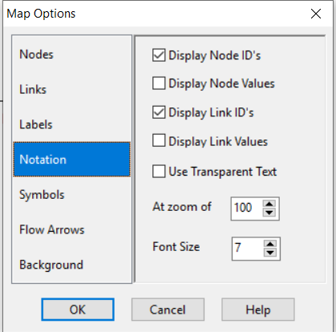

Figure2: Project defaults dialog. Figure3: Map options dialog

Next, we will select some map display options so that as we add objects to the map, we will see their ID labels and symbols displayed. Select **View >> Options** to bring up the Map Options dialog form. Select the Notation page on this form and check the settings shown in Figure 3. Then switch to the Symbols page and check all of the boxes. Click the **OK** button to accept these choices and close the dialog.

Finally, before drawing our network we should ensure that our map scale settings are acceptable. Select **View >> Dimensions** to bring up the Map Dimensions dialog. Note the default dimensions assigned for a new project. These settings will suffice for this example, so click the **OK** button.

## **Drawing the Network:**

We are now ready to begin drawing our network by making use of our mouse and the buttons contained on the Map Toolbar shown below. (If the toolbar is not visible then select **View >> Toolbars >> Map**).



First, we will add the reservoir. Click the Reservoir button image4. Then click the mouse on the map at the location of the reservoir (somewhere to the left of the map). Next, we will add the junction nodes. Click the Junction button image5 and then click on the map at the locations of nodes 2 through 7. Finally add the tank by clicking the Tank button image6 and clicking the map where the tank is located. At this point the Network Map should look something like the drawing in Figure 4.

Next, we will add the pipes. Let’s begin with pipe 1 connecting node 2 to node 3. First click the Pipe button image8 on the Toolbar. Then click the mouse on node 2 on the map and then on node 3. Note how an outline of the pipe is drawn as you move the mouse from node 2 to 3. Repeat this procedure for pipes 2 through 7. Pipe 8 is curved. To draw it, click the mouse first on Node 5. Then as you move the mouse towards Node 6, click at those points where a change of direction is needed to maintain the desired shape. Complete the process by clicking on Node 6. Finally, we will add the pump. Click the Pump button image9, click on node 1 and then on node 2.

Next, we will label the reservoir, pump and tank. Select the Text button image10 on the Map Toolbar and click somewhere close to the reservoir (Node 1). An edit box will appear. Type in the word SOURCE and then hit the **Enter** key. Click next to the pump and enter its label, then do the same for the tank. Then click the Selection button image11 on the Toolbar to put the map into Object Selection mode rather than Text Insertion mode.

At this point we have completed drawing the example network. Your Network Map should look like the map in Figure1. If the nodes are out of position you can move them around by clicking the node to select it, and then dragging it with the left mouse button held down to its new position. Note how pipes connected to the node are moved along with the node. The labels can be repositioned in similar fashion. To re - shape the curved Pipe 8:

1. First click on Pipe 8 to select it and then click the image12 button on the Map Toolbar to put the map into Vertex Selection mode.
2. Select a vertex point on the pipe by clicking on it and then drag it to a new position with the left mouse button held down.
3. If required, vertices can be added or deleted from the pipe by right- clicking the mouse and selecting the appropriate option from the popup menu that appears.
4. When finished, click image13 to return to Object Selection mode.

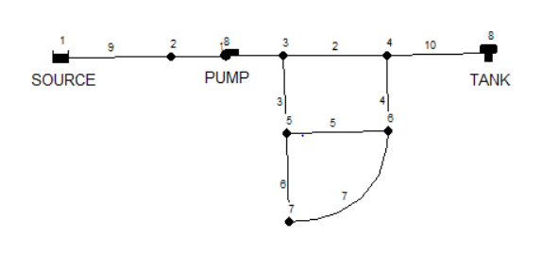

## **Setting Object Properties:**

As objects are added to a project, they are assigned a default set of properties. To change the value of a specific property for an object one must select the object into the Property Editor (Figure 5):

* Double-click the object on the map
* Right-click on the object and select **Properties** from the pop-up menu that appears
* Select the object from the Data page of the Browser window and then click the Browser’s Edit button image14

Whenever the Property Editor has the focus you can press the F1 key to obtain fuller descriptions of the properties listed.

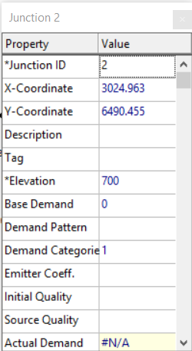

Figure5: Property editor.

Let us begin editing by selecting Node 2 into the Property Editor as shown above. We would now enter the elevation and demand for this node in the appropriate fields.

For the reservoir you would enter its elevation (700) in the Total Head field. For the tank, enter 830 for its elevation, 4 for its initial level, 20 for its maximum level, and 60 for its diameter. For the pump, we need to assign it a pump curve (head versus flow relationship). Enter the ID label 1 in the Pump Curve field.

Next, we will create Pump Curve 1. From the Data page of the Browser window, select Curves from the dropdown list box and then click the Add button image16. A new Curve 1 will be added to the database and the Curve Editor dialog form will appear (see Figure 6). Enter the pump’s design flow (600) and head (150) into this form. EPANET automatically creates a complete pump curve from this single point. The curve’s equation is shown along with its shape. Click **OK** to close the Editor.

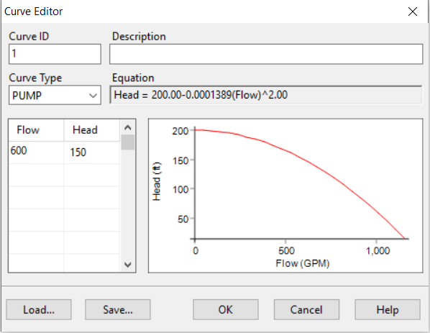

Figure 6: Curve editor.

## **Saving and Opening Projects:**

1. From the **File** menu select the **Save As** option.
2. In the Save As dialog that appears, select a folder and file name under which to save this project. We suggest naming the file **tutorial.net**. (An extension of **.net** will be added to the file name if one is not supplied.).
3. Click **OK** to save the project to file.

The project data is saved to the file in a special binary format. If you wanted to save the network data to file as readable text, use the **File >> Export >> Network** command instead.

To open our project at some later time, we would select the **Open** command from the **File** menu.

## **Running a Single Period Analysis:**

To run the analysis, select **Project >> Run Analysis** or click the Run button image18 on the Standard Toolbar.

If the run was unsuccessful then a Status Report window will appear indicating what the problem was. If it ran successfully you can view the computed results in a variety of ways. Try some of the following:

* Select Node Pressure from the Browser’s Map page and observe how pressure values at the nodes become color-coded. To view the legend for the color-coding, select **View >> Legends >> Node** (or right- click on an empty portion of the map and select Node Legend from the popup menu). To change the legend intervals and colours, right-click on the legend to make the Legend Editor appear.

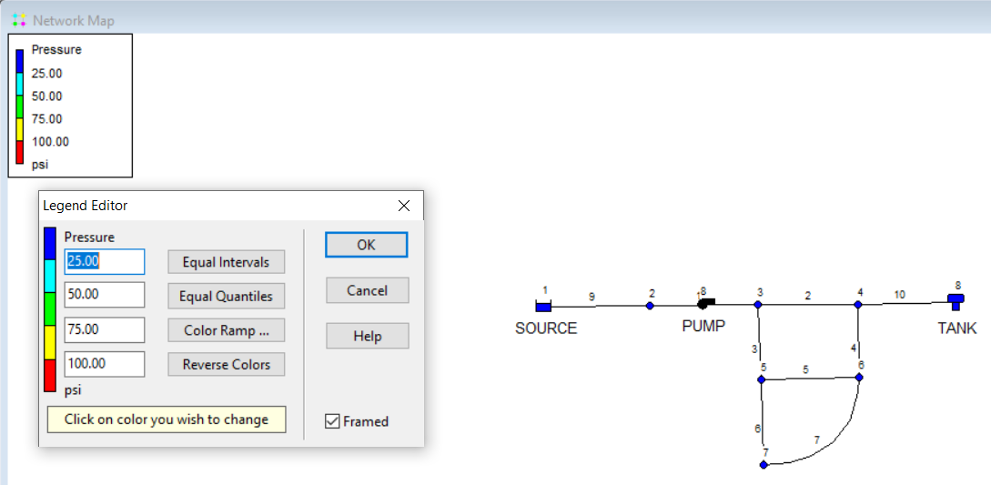

* Bring up the Property Editor (double-click on any node or link) and note how the computed results are displayed at the end of the property list.
* Create a tabular listing of results by selecting **Report >> Table** (or by clicking the Table button image19 on the Standard Toolbar). Figure 7 displays such a table for the link results of this run. Note that flows with negative signs means that the flow is in the opposite direction to the direction in which the pipe was drawn initially.

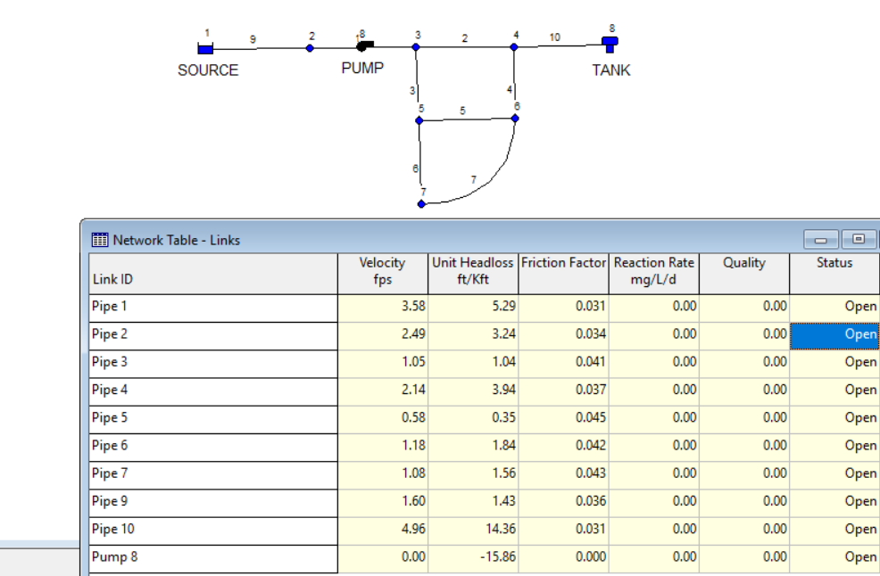

Figure 7: Results

## **Running an Extended Period Analysis:**

To make our network more realistic for analysing an extended period of operation we will create a Time Pattern that makes demands at the nodes vary in a periodic way over the course of a day. For this simple example we will use a pattern time step of 6 hours thus making demands change at four different times of the day. We set the pattern time step by selecting Options-Times from the Data Browser, and entering 6 for the value of the Pattern Time Step. Let’s use a 3-day period of time (enter 72 hours for the Duration property).

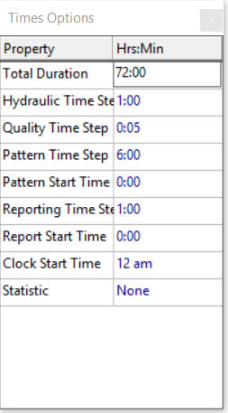

To create the pattern, select the Patterns category in the Browser and then click the Add button image22. A new Pattern 1 will be created and the Pattern Editor dialog should appear. Enter the multiplier values 0.5, 1.3, 1.0, 1.2 for the time periods 1 to 4 that will give our pattern a duration of 24 hours. The multipliers are used to modify the demand from its base level in each time period. Since we are making a run of 72 hours, the pattern will wrap around to the start after each 24-hour interval of time.

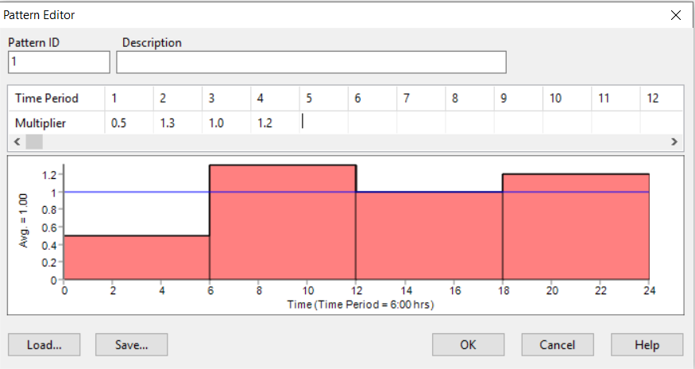

We now need to assign Pattern 1 to the Demand Pattern property of all of the junctions in our network.  If you bring up the Hydraulic Options in the Property Editor you will see that there is an item called Default Pattern. Setting its value equal to 1 will make the Demand Pattern at each junction equal Pattern 1, as long as no other pattern is assigned to the junction.

Next run the analysis (select **Project >> Run Analysis).**

For extended period analysis you have several more ways in which to view results:

* The scrollbar in the Browser’s Time controls is used to display the network map at different points in time. Try doing this with Pressure selected as the node parameter and Flow as the link parameter.
* Add flow direction arrows to the map (select **View >> Options**, select the Flow Arrows page from the Map Options dialog, and check a style of arrow that you wish to use). Then begin the animation again and note the change in flow direction through the pipe connected to the tank as the tank fills and empties over time.
* Create a time series plot for any node or link. For example, to see how the water elevation in the tank changes with time:
  + Click on the tank.
  + Select **Report >> Graph** (or click the Graph button image27 on the Standard Toolbar) which will display a Graph Selection dialog box.
  + Select the Time Series button on the dialog.
  + Select Head as the parameter to plot.
  + Click **OK** to accept your choice of graph.

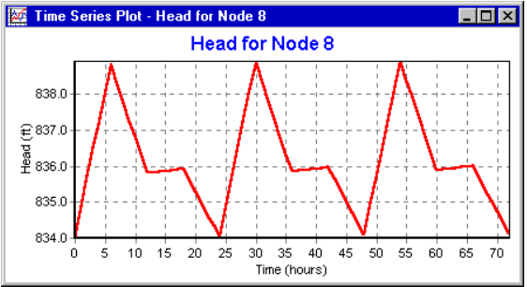

## **Running a Water Quality Analysis:**

Next, we show how to extend the analysis of our example network to include water quality. The simplest case would be tracking the growth in water age throughout the network over time. To make this analysis we only have to select Age for the Parameter property in the Quality Options.

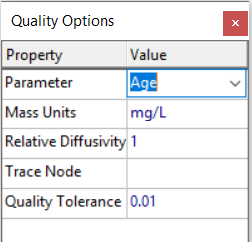

Finally, we show how to simulate the transport and decay of chlorine through the network. Make the following changes to the database:

1. Select Options-Quality to edit from the Data Browser. In the Property Editor’s Parameter field type in the word Chlorine.
2. Switch to Options-Reactions in the Browser. For Global Bulk Coefficient enter a value of -1.0. This reflects the rate at which chlorine will decay due to reactions in the bulk flow over time. This rate will apply to all pipes in the network. You could edit this value for individual pipes if you needed to.
3. Click on the reservoir node and set its Initial Quality to 1.0. This will be the concentration of chlorine that continuously enters the network. (Reset the initial quality in the Tank to 0 if you had changed it.)

Now run the example. Use the Time controls on the Map Browser to see how chlorine levels change by location and time throughout the simulation. Create a reaction report for this run by selecting **Report >> Reaction** from the main menu. It shows on average how much chlorine loss occurs in the pipes as opposed to the tank. The term “bulk” refers to reactions occurring in the bulk fluid while “wall” refers to reactions with material on the pipe wall. The latter reaction is zero because we did not specify any wall reaction coefficient in this example.

